COS30020 Lab 3: Functions and Control Structures

References:

* Chapter 2 of your eText PHP Programming with MySQL.
* PHP Control Structures: <http://www.php.net/manual/en/language.control-structures.php>
* PHP User-defined Functions: <http://www.php.net/manual/en/functions.user-defined.php>

**Aims:**

* To be able to use various control structures and develop your own functions.

## Getting Started:

Create a new folder ‘**lab03**’ under the unit folder on the mercury server

~/*cos30020/www/htdocs* folder on mercury. Save today’s work in this lab03 folder.

You could also create and link an external stylesheet, to the pages, and this should be valid CSS3.

# Task 1: Using if and while statements (9 points)

### Step 1:

Create a file **mathfunctions.php** to contain a function called factorial that accepts a positive integer and returns its factorial value. A factorial of a non-negative integer n, denoted by n!, is the product of all positive integers less than or equal to n. For example,

5! = 5 x 4 x 3 x 2 x 1 = 120

<?php

function factorial ($n) { // declare the factorial function

$result = 1; // declare and initialise the result variable

$factor = $n; // declare and initialise the factor variable while ($factor > 1) { // loop to multiple all factors until 1

$result = $result * $factor;

$factor--; // next factor

} // Note that the factor 1 is not multiplied return $result;

}

?>

### Step 2:

Create a file **factorial.php** that will include the file **mathfunctions.php** in order to access the defined functions in the file. It should also receive an input from **factorialform.php** from Step 3 via GET method, and check if the input is a positive integer then output its factorial value. Otherwise, it should generate an appropriate error message.

<!DOCTYPE html>

<head>

<meta http-equiv="content-type" content="text/html; charset=utf-8" />

<meta name="description" content="Web Application Development :: Lab 1" />

<meta name="keywords" content="Web,programming" />

<title>Using if and while statements</title>

</head>

<body>

<?php

include ("mathfunctions.php");

?>

<h1>Web Programming - Lab 3</h1>

<?php

if (isset ($_GET[" "])) { // check if form data exists

$num = $_GET[" "]; // obtain the form data

if ( ) { // check if $num is a positive number

if ($num == round ($num)) { // check if $num is an integer echo "<p>", $num, "! is ", factorial ($num), ".</p>";

} else { // number is not an integer echo "<p>Please enter an integer.</p>";

}

} else { // number is not positive echo "<p>Please enter a positive integer. </p>";

}

} else { // no input

echo "<p>Please enter a positive integer.</p>";

}

?>

</body>

</html>

### Step 3:

Create a file **factorialform.php** that contains a form with a single text box that allows a user to enter a number, and submit it to **factorial.php**.

<!DOCTYPE html>

<html lang="en" lang="en" >

<head>

<meta http-equiv="content-type" content="text/html; charset=utf-8" />

<meta name="description" content="Web Application Development :: Lab 3" />

<meta name="keywords" content="Web,programming" />

<title>Using if and while statements</title>

</head>

<body>

<h1>Web Application Development - Lab 3</h1>

<form action = method = >

</form>

</body>

</html>

Test in the browser.

# Task 2: Using if statement (3 points)

### Step 1:

Create a file **leapyear.php** with a script that tests if a variable value is a number, and if it is a leap year, and prints a message stating whether the year is a *standard year* or a *leap year*.

If the numerical value for a year is divisible by 4, it is a leap year. However, if the year is also divisible by 100 it is not a leap year, unless the year is also divisible by 400, in which case it is a leap year.

Test in the browser.

### Step 2:

Create a file **leapyearform.php** that contains a form with a single text box that allows a user to enter a year, and submit it to **leapyear.php**.

Change **leapyear.php** to receive the year entered and determine if it is a leap year.

Test in the browser, and check that the pages are valid.

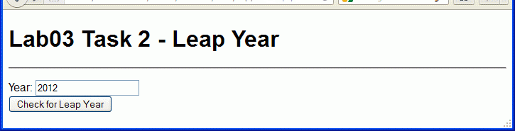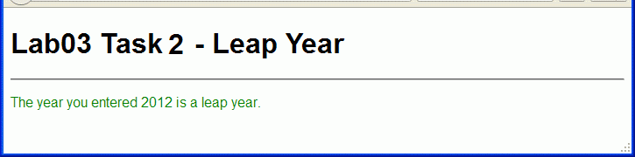

### Step 3:

Modify the script in **leapyear.php** to contain a function **is_leapyear** that accepts a single parameter representing the year. The function returns true if the year is a leap year otherwise false.

Test in the browser.

# Task 3: Implementing loop statements (3 points)

### Step 1:

Create another file **primenumber.php** with a script that determines whether a number between 1 and 999, is a prime number and displays the result with an echo statement.

A prime number is a number that can only be divided by itself or by one. Examples of prime numbers include 1, 3, 5, 7, 13, and 17. You need to use a looping statement to test all division possibilities.

View in the browser.

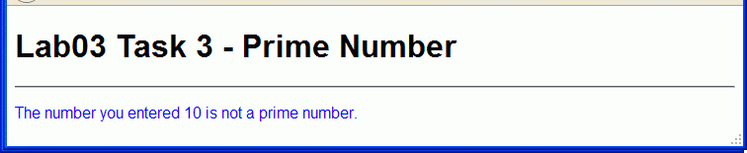

### Step 2:

Create a file **primenumberform.php** that contains a form with a single text box in which users can enter a number, and submit it to **primenumber.php**.

Change **primenumber.php** to receive the number entered and determine if it is a prime number. Test in the browser.

### Step 3:

Modify the script in **primenumber.php** to contain a function **is_prime** that accepts a single integer parameter and returns **true** it is a prime number otherwise **false**.

Test in the browser.

# Extra Challenge:

Save a copy of **leapyear.php** as **leapyear_selfcall.php**.

Copy the form from **leapyearform.php** into **leapyear_selfcall.php** and change the form action to

**leapyear_selfcall.php** and test.

To improve the user interface, check **if** no form input has been entered, using **isset** function, so that a check and display is only made when a value is submitted. <http://php.net/manual/en/function.isset.php>

